**Introduction to Selenium**

**Selenium is probably the best option for automated testing of Websites today.**

**What is Selenium?**

Selenium automates browsers, and a portable testing API for web applications.

Selenium is a free (Open source) automated testing suite for web applications across different browsers and platforms.

**Open Source tool popularity**

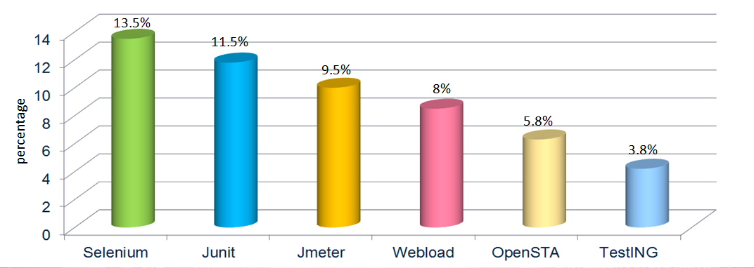

*The graph shows the popularity of Selenium along with other open source automation testing tools.*

**Why Selenium?**

1. Open source is the Key
2. Reuse test script in automated test framework
3. Support Java script and Ajax technology
4. Popular for quick cycle development as Agile
5. Supports all major language, Browsers and Operating system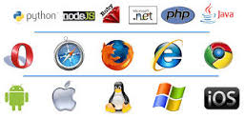

**Selenium Suite:**

Selenium is not just a tool but suite of software’s, each catering to different needs of an organization.

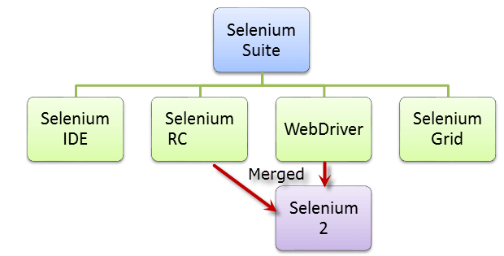

**Selenium IDE:**

PROS:

1. FireFox plugin with Record/Playback, Edit and Debug test in Browser.
2. Script gets recorded in Selenese language
3. It helps in exporting test that can be executed in Selenium RC & webDriver.
4. It allows the user to add Assertions and Verifications.

CONS

1. Available only in Firfox Browser
2. No support for iteration and conditional operator
3. Test execution is slow compare to RC & Webdriver

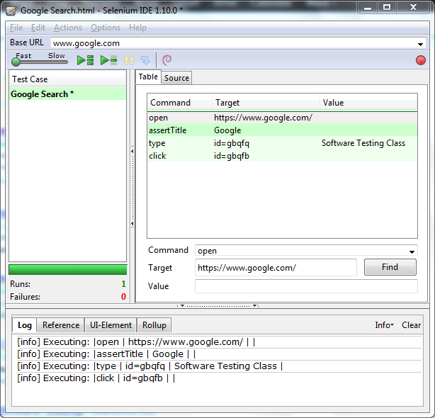

**Selenium RC:**

1. Selenium RC needs Selenium RC server to be running

**Selenium WebDriver:**

|  |  |
| --- | --- |
|  |  |

1. Simpler Installation compare to Selenium RC
2. It implements a more modern and stable approach
3. It supports all major languages, Browsers and Operating Systems.
4. WebDriver, unlike Selenium RC, does not rely on JavaScript for Automation
5. It controls the Browser by directly communicating with it.

**Selenium Grid:**

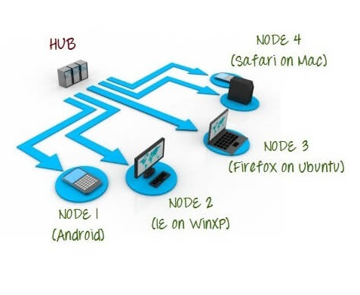

1. Runs multiple tests on different machines against different browsers and operating systems in parallel by using HUB & NODE.
2. Supports distributed test execution.
3. It’s a time effective technique to run the test

References: [www.guru99.com](http://www.guru99.com), [www.wordpress.com](http://www.wordpress.com)